
Available online at www.sciencedirect.com
SCIENCE tft) DIRECT
Computer Communications xx (2005) 1-8

www.elsevier.com/locate/comcom
An efficient traffic engineering approach based on flow distribution
and splitting in MPLS networks
T.J. Shi *, G. Mohan
National University of Singapore, 10 Kent Ridge Crescent, Singapore 119260, Singapore
Abstract
This paper develops an efficient method based on traffic flow distribution and splitting for traffic engineering in the MPLS networks. We define flow distribution as selecting one of the available label switch paths (LSPs) to carry one aggregated traffic flow. Flow splitting is, however, the mechanism designed for multiple parallel LSPs to share one single aggregated flow. Our studies show that flow distribution and flow splitting approaches readily solve the routing problems such as bottleneck and mismatch problems. An algorithm based on network bandwidth utilization is also proposed to integrate both approaches. The simulation results presented at the end of the paper demonstrate the effectiveness of the proposed approaches.
© 2006 Published by Elsevier B.V.
Keywords: MPLS; Traffic engineering; Flow shaping; Flow splitting; Flow aggregation
1. Introduction
Multi protocol label switching (MPLS) [1] is well known for its advantages in traffic engineering (TE) [2,3]. A salient feature of MPLS is that it allows multiple label switch paths (LSPs) to be set up statically between a pair of source and destination nodes. This is usually performed through path establishment protocols such as CR-LDP [4] or RSVP-TE [5]. From internet service providers' (ISPs) point of view, multiple LSPs are necessary for redundancy purpose, due to physical constraints and as a result of incremental capacity upgrading.
The ability that MPLS networks can send packets through prescribed non-shortest paths is ideal for constraint based routing or explicit routing. This is different from traditional hop-by-hop based routing such as shortest path algorithm, which searches for only one shortest path among many possible ones by the participating routers. The edge routers at the boundary of the networks have no control over the routes that the admitted packets travel along with. In MPLS networks, on the contrary, the label edge routers (LER) make the routing decisions. Their knowledge of the individual LSP utilization status is a result of information flooding from the underlying protocols such as open shortest path first (OSPF) or intermediate system to intermediate system protocol (IS-IS).
* Corresponding author E-mail address: elegm@nus.edu.sg (T.J. Shi).
The label switch routers (LSRs) inside the network serve merely as switches--forward the packets based on the preset label mapping rules. Corresponding to the functions of LER in the MPLS networks, this paper deals with the state dependent traffic engineering problem-routing the incoming traffic flows over the multiple preset LSPs based on the network state.
Frequently, traffic flows are subject to flow shaping before the routing decision is made. This is normally due to quality of service (QoS) considerations and it produces aggregated traffic flows [6]. In contrast with this QoS-based flow shaping concept, we propose the concept of routing based flow shaping i.e. flow shaping operates on the aggregated traffic flows, which helps increase the efficiency of routing. Accordingly, we classify the routing techniques broadly to two approaches. One is what we call flow distribution—it takes no further action on the aggregated traffic flow and merely selects one of the available LSPs to carry the entire flow. Fair amount of research work has been done under this category. Minimum interference routing algorithm (MIRA) [7] and its improved version [8] propose that a routing decision should be made with minimal interference to other paths, which is computationally expensive. Stochastic performance comparison routing algorithm (SPeCRA) [9] uses stochastic measures to dynamically select the best routing algorithms. In [10], an integrated shortest path and nearest capacity first algorithm to tackle the mismatch routing problems is presented. The other approach—flow splitting—performs flow shaping by splitting one single aggregated traffic flow to several sub-flows and maps them to several LSPs for onward transmission. Relatively little work
has been done in this area. In [11], a delay-based measurement technique is used to decide on the splitting proportion over two parallel LSPs. MPLS adaptive traffic engineering (MATE) [12] focuses on distributing the best effort traffic over multiple
LSPs.
Apart from the routing based flow shaping concept, we also present an efficient algorithm that makes the routing based flow shaping decisions. The choice of flow splitting or flow distribution is made upon the information gathered from a first in first out (FIFO) queue of most recent network utilization status. In Section 2, we state the definitions and assumptions in our work. Flow distribution and splitting concepts are then discussed in Section 3. In Section 4, we describe the proposed algorithms as well as related mathematical analysis in details. In Section 5, we study the performance of the proposed algorithms and show that they solve the classical bottleneck and mismatch network problems. Section 6 concludes the paper.
2. Definitions and assumptions
2.1. Aggregated traffic flow
The primary role of the transportation layer protocols is to ensure the end-to-end data communication. Here we define the ordered unidirectional sequence of packets that belong to the same pair of connection end points as an application flow. Since there might be multiple communication processes within one host, e.g. email, http and multimedia streams, the conglomeration of all the application flows inside that host forms the traffic flow.
Further, when the traffic flows are routed for onward transmission through the backbone networks, they are normally aggregated at the ingress edge router and redistributed at the egress router to form what we call an aggregated traffic flow. The individual traffic flow then becomes the constituent traffic flow of that particular aggregated traffic flow. In this paper, the aggregated traffic flow might be subject to further partition to form sub-flows. Hence, the transmission entities that can exist in the LSPs are either aggregated traffic flows in case of flow distribution or sub-flows in case of flow splitting.
2.2. Setting up of LSPs and parallel LSPs
In this paper, the LSPs for each source-destination node pair are pre-calculated using the offline algorithm, such as K shortest path algorithm [13], subject to the physical network constraints, and are set up statically. In the following part of the paper, we call the multiple pre-setup LSPs that serve the same pair of source and destination LERs as parallel LSPs.
3. Traffic flow shaping
We discuss the flow shaping related actions performed by an LER in this section. Flow shaping mainly involves manipulating the incoming network traffic on the flow basis. Traditionally, flow aggregation as a form of flow shaping is enforced to facilitate the QoS handling [6]. In the paper, we propose the concept of routing based flow shaping or flow manipulation for the benefit of the network resource utilization. Our proposed routing based flow shaping takes place after the QoS based one. It either distributes or splits the aggregated traffic flow—the product of QoS based traffic shaping--so as to maximize the routing efficiency. Fig. 1 illustrates this concept.
3.1. Flow aggregation
Since MPLS is essentially serving the core transportation networks, the incoming traffic requests arrive from various subnetworks or access networks. As a result, they differ significantly in terms of traffic volumes and QoS requirements. It is therefore necessary to perform flow aggregation—both from the traffic QoS point of view and network management point of view.
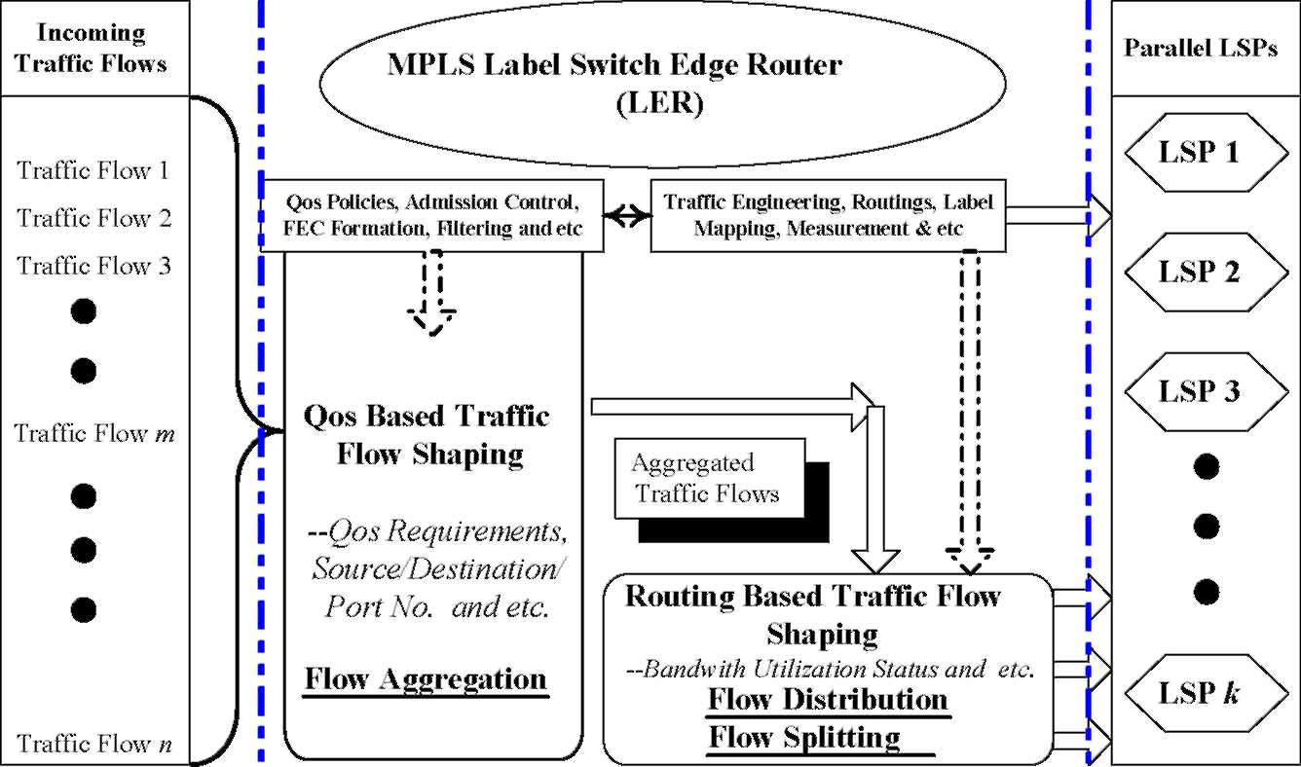
2
Fig. 1. Traffic flow shaping in MPLS LERs.
In order to ensure proper QoS handling of the traffic, the LERs of the MPLS network classify the different traffic flows according to their traffic class by setting the proper value of the 3 bit Class of Service (CoS) field within the MPLS Label Stack¹ [6]. The LERs then aggregate the traffic flows according to CoS value, source, destination and TCP/UDP triple to form the aggregated traffic flow as defined in Section 2. Since traffic flows are usually of fine granularity as indicted by PASTE [6], the aggregated traffic flow shares the same forwarding state and/or QoS resource reservation requirements. Note that the number of aggregated traffic flow is independent of the amount of traffic so when the traffic volume is increased, the amount of traffic on each aggregated traffic flow is raised. Flow aggregation also helps to simplify the network management and increases the efficiency of the scheduling mechanisms by requiring less number of queues [14,15].
3.2. TCP flow level status
An important characteristic of the current Internet traffic pattern is TCP domination. Since over 90% of the current Internet traffic is TCP traffic [16], care must be taken to maintain the integrity of the TCP flow status when we exercise traffic engineering in the third layer. If the TCP flow status is disrupted, packets from the same TCP flow might reach the destination host in a highly disordered manner. This is undesirable for TCP applications as this not only causes excessive reordering burden but also renders a wrong impression to TCP that congestion occurs. TCP will consequently decrease the size of the window of the TCP flows, which leads to a deteriorated performance.
TCP provides function based connection-oriented services so the minimal requirement for underlying routing protocols is to maintain the TCP flow status on an application basis. This corresponds to maintaining the flow status for the application flow or preferably any further aggregated flows in our definition. Nevertheless, it is not a necessary condition to maintain the flow status on the traffic flow, traffic trunk or the aggregated traffic flow basis.
Practically, the major threat that disrupts the TCP flow status during routing is when packets of the same TCP flow are routed to the destination host over different paths. Different paths vary on traffic conditions so there is no guarantee of the order of the packets traversing through. Therefore, it is ideal that the routing protocols in the third layer ensure the entire TCP flow of packets to go through the same path or, more specifically, LSP in case of MPLS networks.
3.3. Flow distribution, splitting and integrity of TCP flows
After the incoming traffic flows are classified and aggregated into aggregated traffic flows, our proposed routing
The CoS field corresponds to the 3 bit field reserved for experimental use in the MPLS label stack, as specified in RFC 3032.
based flow shaping—flow distribution or flow splitting—takes place.
By definition, flow distribution basically chooses one of the parallel LSPs to carry the entire aggregated traffic flow. All the packets that belong to one particular aggregated traffic flow are safely routed to one LSP so the integrity of the constituent traffic flows is guaranteed.
Flow splitting, however, partitions the respective traffic trunks or aggregated traffic flows into the sub-flows so that several parallel LSPs share the load. We show in the subsequent sections that this is particularly useful to increase the overall network resources utilization. Note that the entity that is subject to splitting here is the aggregated traffic flow or traffic trunk i.e. different traffic flows or worst case application flows within the same traffic trunk may be routed through different LSPs. But as long as we can ensure that one entire traffic flow or application flow traverses along only one LSP, the packets of its constituent application flows are assured to be placed in the same LSP. Consequently, the TCP flow integrity is preserved.
It is also worth noting that the number of traffic flows within each aggregated traffic flow is abundant. They just share the same CoS as well as the same address space of the backbone networks—the same pair of ingress and egress LERs in case of MPLS networks. These traffic flows need not originate from nor end with same hosts as long as they are geographically similar enough to be served by the same LER. Theoretically, if ingress LER A is serving M number of hosts and LER B N hosts, potentially the number of traffic flows within that particular traffic trunk is O(MXN). Also, as mentioned earlier, the increase in the amount of the traffic merely leads to the corresponding rise in the traffic volumes of the aggregated traffic flow. Hence, there are constantly available traffic flows for the splitting to carry out.
Lastly, the flow splitting action is invisible to the other routers, switches and LSRs since all of them are MPLS Layer network elements. On the condition that the TCP flow status is preserved, the exercise of flow splitting in the network layer is also transparent to the end hosts where TCP provides the connection-oriented services.
3.4. Routing based flow shaping, FEC and traffic trunks
Flow distribution and flow splitting discussed above correspond to the defined LER functions of assigning the packets to appropriate forward equivalence class (FEC) [ ]. This is normally performed by inserting the proper MPLS labels into the packet headers. Logically, traffic flows are thus mapped to the available parallel LSPs and those traffic flows being mapped to the same LSP form the traffic trunk as defined in [6]. In case of flow distribution, only one FEC is created and all the packets that belong to the same aggregated traffic flow are mapped to the same LSP. Flow splitting, on the other hand, creates multiple FECs so that the traffic flows within one single aggregated traffic flow are assigned different MPLS labels and are mapped to different LSPs accordingly. In this manner, flow
distribution and flow splitting are easily incorporated into the general MPLS and PASTE framework.
3.5. Flow splitting implementation techniques
From the implementation perspective, the flow splitting can be performed on the individual packets. The most popular splitting algorithms are hash based. Direct hashing applies the hash function to the routing information of packet notably the five-tuple and re-distributes the packets according to the output value [10,15]. For asymmetrical splitting, table-based hashing is preferred, for which an intermediate table index is used to facilitate the re-distribution [15].In [15], it is also demonstrates that table-based hashing produces precise asymmetrical splitting result.
4. The proposed algorithms
In this section, we discuss the flow distribution, flow splitting and the integration algorithms. Markov queuing models are subsequently applied for the analysis of the performance of the proposed algorithms.
4.1. Flow distribution algorithm (FD)
For each ingress and egress LER (s,d), we have a finite set
^{P}(s,d) = (^{p}(s,d); ^{pNp}d)} ^{where} ^{p}(s,d)^{is} ^{the} ^{capacity} ^{of} parallel LSPs that connects (s,d). The total number ofavailable LSPs |P(_{s}4)| is thus N_{p}. For eachp(_{s} _{d}), the ingress LER collects its real time available bandwidth h(_{sd}) (through either OSPF or IS-IS) and form the corresponding available bandwidth set B(_{sd}) = |b^{ith}
⁽_{sd}), . We further denote the ratio of the
available bandwidth over its capacity as r(_{s}d):
hi
^{r}(s,d) = ~i- ⁽¹⁾
^{p}(s d)
In addition, we denote the set that contains the ratios r₍^{i}_{s} _{d)}of all the LSPs as R_{(s,d)}. The bandwidth associated with one aggregated traffic flow subject to distribution is denoted by
^{f}(s,d)The flow distribution algorithm first searches for the least utilized LSP r(_{sd)} = min{R(_{sd)}} and places the aggregated traffic flow onto that LSP if b(_{sd}) > f(_{sd}). If the least utilized LSP fails to accommodate the flow, the LER will try the next least utilized LSP. The iteration terminates on the condition that either the aggregated traffic flow is accepted or every available LSP in the set has been checked.
4.2. Flow splitting algorithm (FS)
The flow splitting algorithm is designed for multiple parallel LSPs to share the load of one aggregated traffic flow. The partition rule is inspired by the principle of optimality used by the divisible load theory (DLT) [18]. It argues that the optimal allocation of one computational intensive job to several processors should be implemented such that all the processors should complete their portion of job at the same instant of time. By the same token of argument, we propose that the flow splitting rule should allow all the participating LSPs to contribute their available network bandwidth fairly.
Suppose that at time instant t_{i}, we have N_{p} pre-setup LSPs
P(_{s} , _{d}) = |p<_{s} d) , ■••>p.
^{Np}_{d})}, each with the available bandwidth
B(s , d) = {h(s ,d), h^j)]. Now an aggregated traffic flowf(s,d) is to be mapped to all the LSPs. In order to allow fair splitting, we calculate the bandwidth size for each sub-flow s(_{s} _{d}) by
J = _{f} ^{h(s,d)} ₍₂₎
^{s}(s ,d) = ^{f}(s ,d) ~n ⁽²⁾
^{N}p
S ^{h}(s , d) n=1
The LER first ensures that h^{n}_{s} _{d}) R f(_{s;d}), and then it will
n= 1
check each LSP for h(_{s} _{;d}) R s(_{s} _{d}). That is to say, if the flow splitting is deemed necessary, the aggregated flow will only be admitted on the condition that the available bandwidth of all the involved LSPs is greater than that of the corresponding assigned sub-flows.
4.3. The integration algorithm (IA)
As we will discuss later, the flow distribution and flow splitting outperform each other under different loads, network topologies as well as average bandwidth request of the aggregated traffic flows. Generally, the flow splitting works well when the network is generally lightly loaded while the flow distribution takes over in the heavily loaded networks. An FIFO queue based network bandwidth utilization measurement algorithm is therefore proposed to select the proper technique that maximizes the call acceptance rate, thus, the overall network resource utilization.
We first introduce the relevant mathematical constructs. For any ordered pair of ingress and egress LERs (s,d), we define the corresponding bandwidth status O_{(s,d)}:
^{n}p _{n} ^{h}(s , d)
O^{(s} ^{,d)} = !Nl- (3)
^{N}p
^{p}(^{n}s d)
n=1
To defend our prediction from the busty nature of the networks, the exponential weighted moving average of the value O(s,d) is used:
Af;* = aO^{(s} ^{,d)} + (1 - a)A^{(s} ^{,d)} (4)
where a (0<a<1) is the weighing factor. Further, each ingress LER maintains an FIFO queue Q^{(s,d)} that stores U most recent A⁽;^{d)} values. A threshold bandwidth status value h(_{s}4)is then chosen based on the historical simple mean (typically 6080% of the mean)--any real time measurement At;^{d)} below this threshold indicates a 'heavy load' signal. The total number of the members inside the FIFO queue Q^{(s,d)} whose value is less than the threshold h(_{s}4) is denoted by u. The ingress LER then compares the quotient u/U against the pre-determined decision
Arrival of Aggregated Traffic Flow at timet
_4_
Update of FIFO Queue gFlow Distribution is Enforced
yC. ., ^\ no
S Distribution \_
mode? yr \ f>7/
Yes
_ _I_
No ^\ ^{M}
^{YeS} Initiate New
^fjheckmdecisi^v Round of _ Flow Splitting _
\.«/[/>iC(_{Il}ji/"^ Splitting is Enforced
Fig. 2. Flowchart of the integration algorithm.
frequency k(_{sd}) and consequently makes the decision. Flow distribution is enforced if the network is busy most of the time within our observation window or else flow splitting is carried out to 'stretch' the network. The entire integration algorithm is illustrated in the following flow chart (Fig. 2).
4.4. Mathematical models and analysis
We study the performance of the proposed algorithms through mathematical analysis in this section. Since MPLS based networks are usually large in scale and typically serve as backbone networks, the incoming traffic flows are composed of large number of similar and independent processes so we can model them as Poisson process [17] with mean arrival rate l.If there is only one LSP between s and d with bandwidth of size nm (or service rate in queuing theory), we can model the system as the single server Markov queuing system with Poisson arrival process and exponential service time distribution or M/ M/1 Markov queue. In reality, there are more than one LSP that connect the LER pair (s,d). If, for the simplicity of the mathematical analysis, we assume all these n parallel LSPs are of uniform bandwidth m, this comes out to be the M/M/n Markov queuing system with the same amount of service rate or bandwidth nm.
From the classical Markov queuing theory, the average sojourn time or average packet delay T¹ for the M/M/1 Markov queue and T for the M/M/n Markov queue are given by E[T¹] = — + ^{Pq} . where P\ = p = -
1 P'E[T¹
^{n}] =- +-^{q}—,
m nm- -
where
_{P}n = ^{(np/)n} ^{p}0
^{Pq} n! 1 -p(np⁰
⁰) + (npT 1 #i 0 ⁻¹
^{i!} ^{n!} ¹ ⁻ ^{p0} p = —
nm
(5) (6)
(7) (8) (9)
In the above equations, P¹_{q} and P^{n}_{q} are the probabilities that upon a packet arrival, all LSPs are fully occupied for the single LSP case and the multiple LSP case, respectively. Also, p denotes the traffic intensity, p¹ denotes the utilization of any individual LSP and p₀ denotes the probability that the network is idle. When the network is lightly loaded, we observe that the average packet delay is about n times longer for the case of multiple LSPs than the case of single LSP (Eq. (10)). This is due to the fact that the resources of the other LSPs are not
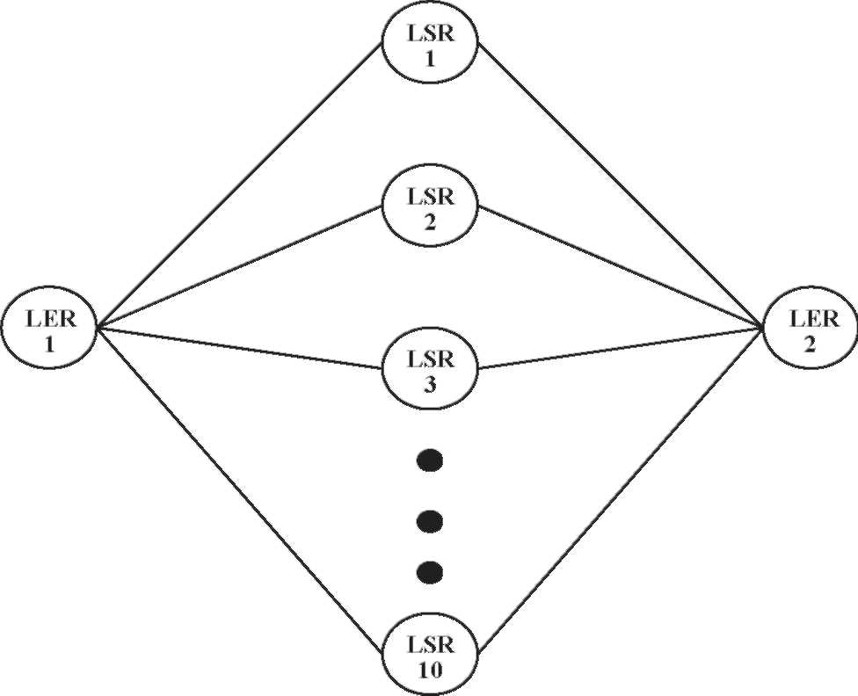
Fig. 3. Network topology 1.
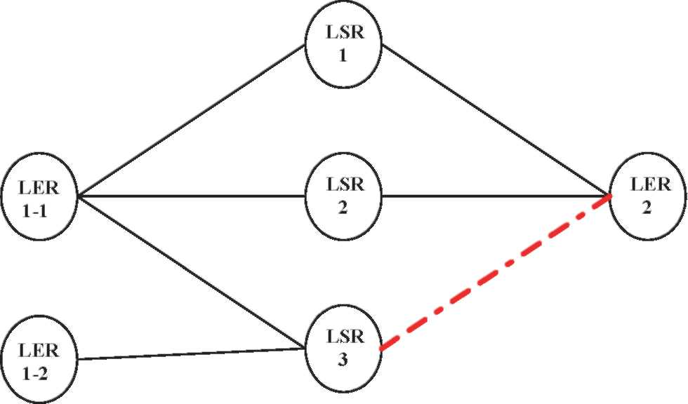
partitioning the aggregated flow into finer grained sub-flows. In its limiting case, the n LSP Markov queuing system converges to the single LSP Markov queuing system from the network utilization point of view though this is not normally the case since the aggregated flows cannot be split arbitrarily.
However, flow splitting does not always outperform flow distribution. Flow splitting attempts to allocate the aggregated traffic flow to multiple parallel LSPs. Hence, if the available bandwidth of any one of the designated LSPs is less than the allocated amount (Eq. (2)), the whole aggregated flow has to be rejected since we cannot carry partial flows. The utilization of the individual LSP is given by (Eq. (9)) and as we can see with the increase of the probability Pf^{i)} of finding them free with certain amount of bandwidth decreases (Eq. (11)). Accordingly, the probability PF^{s}'^{d)} of admitting an aggregated traffic flow is reduced exponentially (Eq. (12)).
P^{(i)} = 1-p(i) = 1— R |^ (11)
^{nm}i ^{h}(s⁾d)
P⁽_{F}^{s} ^{d} P⁽_{f}^{i} (12)
i 1
This is particularly the case when the overall network is heavily loaded. Note that individual LSP utilization is not relevant here, as with the proposed algorithms, the MPLS network is treated more as a whole. We, therefore, propose (Eq. (3)) as a measurement of the network utilization for each pair of (s,d) and depending on the measurement value, flow splitting and flow distribution are then applied.
Fig. 4. Network topology 2.
utilized at all as all the traffic are routed to their designated
LSPs only.
_{E} _{T}1
-!—] zn, when p = P'_{q} = PI = 0 (10)
E[Tn]
To overcome this non-optimality, flow distribution, thus, distributes the aggregated traffic flows according to the utilization status of individual LSPs (Eq. (1)) so as to even out the offered traffic loads and increase the efficiency of the overall network resource. Flow splitting can be viewed as a more 'aggressive' form of averaging the traffic load by further
5. Performance study
In this section, we first demonstrate that the proposed integration algorithm makes accurate decision of choosing the routing based flow shaping techniques using network topology 1(Fig. 3). After that, we show how flow distribution and splitting readily resolve the bottleneck network problems through network topology 2 (Fig. 4) and mismatch problems through network topology 3 (Fig. 5). Simulations done using network topology 2 and 3 also reinforce the effectiveness of the integration algorithm. Flow distribution (FD) and flow splitting (FS) outperform each other under different circumstances in
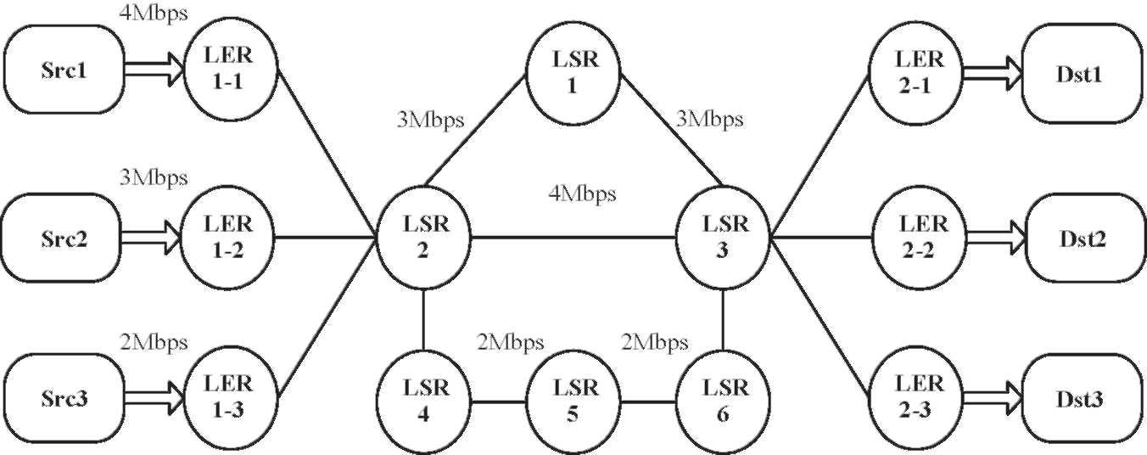
Fig. 5. Network topology 3.
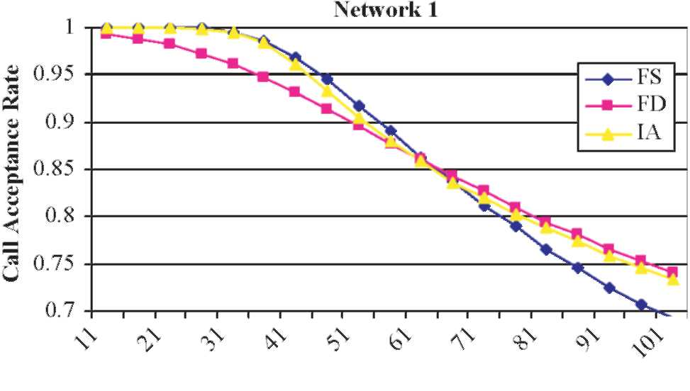
Offered Traffic (Erl)
Fig. 6. Effectiveness of integration algorithm under various traffic loads.
both topologies; however, the integration algorithm (IA) always chooses the better performing technique. Unless otherwise stated, the offered traffic load here is Poisson distributed with average holding time 1000. Also, we measure the network performance mainly using the call acceptance rate.
5.1. Effectiveness of the integration algorithm
We analyze the performance of the integration algorithm using the network topology 1 (Fig. 3) adapted from [12]. There are 10 preset LSPS between the single pair of ingress and egress LERs, each of capacity 2000. The offered traffic is Poisson distributed with average bandwidth 400. Fig. 6 plots the call acceptance rate under different loads of the three proposed algorithms; we can observe that flow splitting performs better when the offered load is light while its result deteriorates significantly under heavy load. When the network is relatively free, flow splitting efficiently 'overstretching' the network by making full use of the tidy unutilized bandwidth in each LSP. As the network gets busier, flow distribution 'defends' the network from being overloaded and maintains the overall network balance on the LSP basis. The integration algorithm, however, is able to track the overall network status and switch between flow distribution and splitting accordingly for the optimized network performance. Fig. 7 shows the amount of aggregated traffic flows subject to distribution and splitting, respectively, under different loads. Our simulation results also show the effectiveness of the integration algorithm for other average bandwidth values. Note that the simulation result is consistent with our mathematical analysis previously.
Network 1
500000
450000
400000 | 350000 g 300000 =3 250000 6 200000
^{N}150000 100000 50000
0
-^t^r^^vi -^r^r^^"n-^ r^r^^"n-— -^-^(NfNr^ ^t-^t-<n<n^ot^ r^oooo^o
(Offered Traffic / Erl)
Fig. 7. Amount of flow distribution and splitting under various traffic loads.
Fig. 8. (a) Solving the bottleneck network problem under various traffic loads (FD outperforms FS). (b) Solving the bottleneck network problem under various traffic loads (FS outperforms FD).
5.2. Solving the bottleneck problem
Fig. 4 depicts a classical bottleneck problem that LER1-1 and LER1-2 are contending for bottleneck link (dotted line in the figure). Each link in the network is of uniform capacity 2000.The non-ideal case performance is that LER1 tries to pump in traffic flows from LSP3 first then it reverts to LSP2 and LSP1 only if LSP3 is fully utilized. The ideal case is that LER1 attempts LSP1 and LSP2 first before it eventually touches on LSP3.By doing so, LER1 successfully avoids the bottleneck link. Our simulation results (Fig. 8(a)) show that the flow distribution produces near ideal result when the average bandwidth (100) of the aggregated traffic flow is relatively small. Its performance, however, is surpassed by flow splitting as the average bandwidth rises to 500 (Fig. 8(b)). This behavior follows the arguments in the previous Section 5.1.In both cases, the integration algorithm successfully selects the flow shaping technique that optimizes the network performance.
5.3. Solving the mismatch problem
The mismatch problem (Fig. 5) was considered in [10].It argues that if LER3 with average bandwidth size 2 Mbps starts to transmit traffic first, by shortest path first (SPF) algorithm, the 4 Mb link will be first chosen. At the time when LER1 with 4 Mbps average bandwidth request size begins to pump in
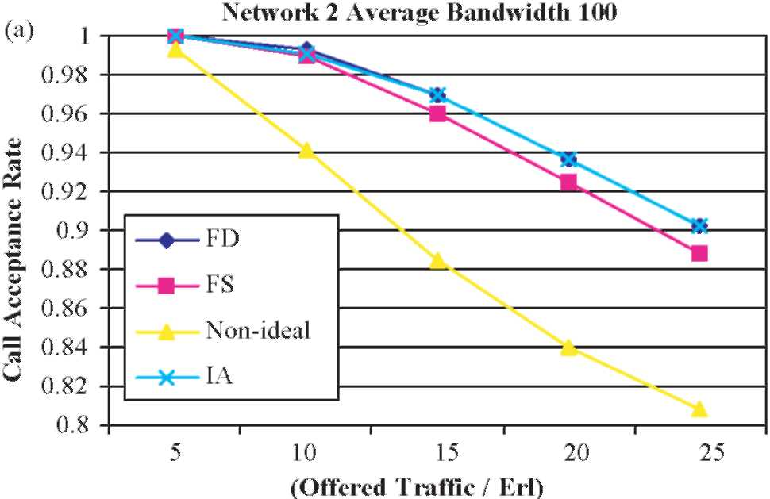
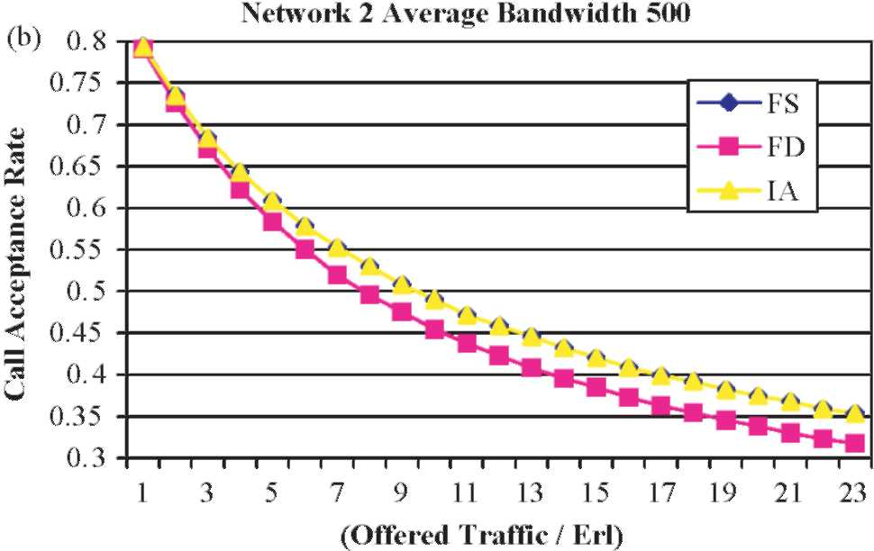
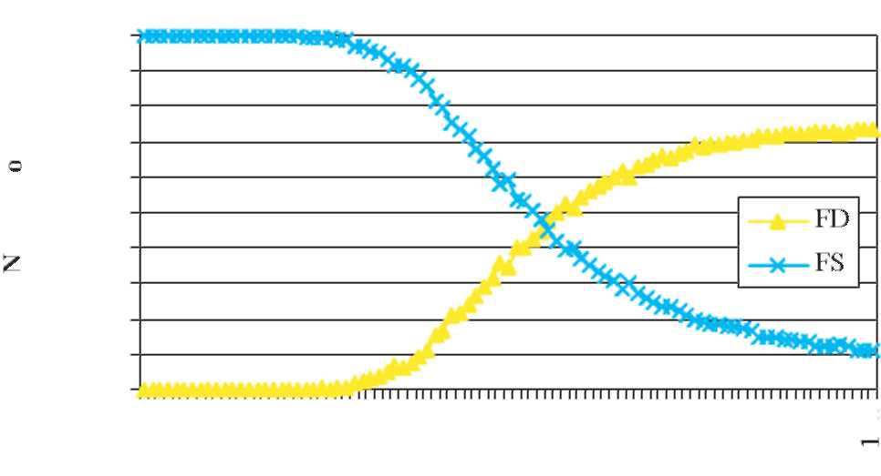
Fig. 7. Amount of flow distribution and splitting under various traffic loads.
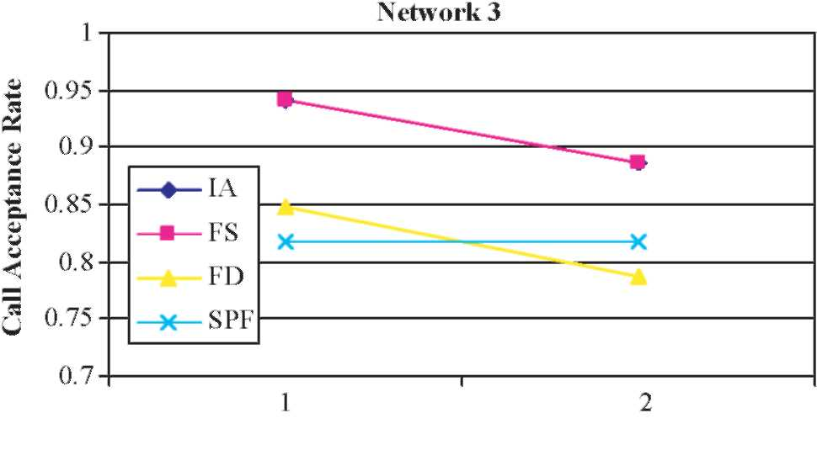
Offered Traffic (Erl)
Fig. 9. Solving the mismatch network problem.
traffic, it will find no single suitable LSP to accommodate them. Since the overall network resource is barely enough, the performance is not satisfactory even if we manually match the LSPs with the LERs. However, our flow splitting technique works particularly well under this situation as it increases the call acceptance rate from 85% to holding time equal to 1 (Fig. 9). Note that in this case, the integration algorithm selects flow splitting all the time and produces the same performance as that of the flow splitting (Fig. 9).
6. Conclusions
In this paper, a new routing based traffic flow shaping concept has been introduced and discussed. Relevant flow shaping methods such as flow distribution, flow splitting as well as the integrated algorithm have been introduced and studied through mathematical analysis and by simulations. Simulations have shown the effectiveness of the proposed flow distribution, flow splitting as well as integration algorithms under different network topologies, average bandwidth sizes of the network traffic and the overall network loads. It has been observed that with the introduction of our new concept of routing based flow shaping, some classical network problem such as bottleneck and mismatch problems could be handled effectively. As for our future work, we are currently developing more rigorous and general mathematical models to examine the factors that affect network performance, both for flow
distribution and for flow splitting. We shall also try to apply the model in a wider sense to include both best effort and QoS traffic.
References
[1] E. Rossen, A. Viswanathan, R. Callon, Multiprotocol Label Switching
Architecture, RFC 3031, Jan. 2001. [2] G. Armitage, The magic behind the myths, IEEE Communications
Magazine (2000).
[3] G. Swallow, MPLS advantages for traffic engineering, IEEE Communications Magazine (1999).
[4] B. Jamoussi, L. Andersson, R. Dantu, L. Wu, P. Doolan, T. Worster, N. Feldman, A. Fredette, M. Girish, E. Gray, J. Heinanen, T. Kilty, A. Malis,
Constraint-Based LSP set up using LDP, RFC 3212, Jan. 2002. [5] D. Awduche, L. Berger, D. Gan, T. Li, V. Srinivasan, G. Swallow, RSVP-
TE: Extensions to RSVP for LSP Tunnels, RFC 3209, Dec. 2001. [6] T. Li, Y. Rekhter, Provider Architecture for Differentiated Services and
Traffic Engineering (PASTE), RFC 2430, Oct, 1998. [7] M. Kodialam, T.V. Lakshman, Minimum interference routing with
application to MPLS traffic engineering, in: Proceedings of INFOCOM,
2000.
[8] B. Wang, X. Su, C.L.P. Chen, A new bandwidth guaranteed routing algorithm for MPLS traffic engineering, in: Proceedings of ICC, 2002.
[9] J.C. de Oliveira, F. Martinelli, C. Scoglio, SPeCRA: a stochastic
performance comparison routing algorithm for LSP setup in MPLS
networks, in: Proceedings of GLOBECOM, 2002.
[10] K. Long, Z. Zhang, S. Cheng, Load balancing algorithms in MPLS traffic
engineering, in: Proceedings of ICC, 2002. [11] D. Gao, Y. Shu, S. Liu, O.W.W. Yang, Delay-based adaptive load
balancing in MPLS networks, in: Proceedings of ICC, 2002. [12] Elwalid, C. Jin, S. Low, I. Widjaja, MATE: MPLS adaptive traffic
engineering, in: Proceedings of INFOCOM, 2001. [13] D. Eppstein, Finding the K shortest paths, Proceedings of the 35th IEEE
Symposium on Foundations of Computer Science, Santa Fe, NM, 1994,
pp. 154-165.
[14] J.A. Cobb, Preserving quality of service guarantees in spite of flow aggregation, IEEE/ACM Transactions on Networking 10 (1) (2002).
[15] Z. Cao, Z. Wang, E. Zegura, Performance of hashing-based schemes for internet load balancing, in: Proceedings of INFOCOM 2000.
[16] K. Thompson, G.J. Miller, R. Wilder, Wide-area internet traffic patterns and characteristics, IEEE Network (1997).
[17] J.W. Roberts, Traffic theory and the internet, IEEE Communications
Magazine (2002).
[18] T.G. Robertazzi, Ten reasons to use divisible load theory, IEEE Computer
Magazine (2003).

